A NOTE FROM THE AUTHOR

Dear Readers:

I’m excited to share a page from my new book, Ghosts, with you.

Ghosts has existed in my head in one form or another since 2002. Catrina and Maya’s world only started to take its current shape in 2012, when I lost my cousin Sabina to a terrible illness. She died at thirteen, her shining light of a personality dimmed too soon. Watching her family grapple and cope with such a great loss had a profound impact on me, and I realized that the story I wanted to tell was about more than just ghosts in the supernatural sense—it was also about love, loss, life, and celebrating those who matter, both before and after they are gone.

I grew up in San Francisco, and often visited the Mission District, where Mexican and Mexican American culture flourished. My family and I enjoyed taking in the incredible murals, as well as the music, cuisine, and language that surrounded us. These outings serve as another major inspiration for Ghosts.

I got my first taste of magical realism in college, where I fell in love with Isabel Allende’s writing. Ever since, I’ve wanted to try my hand at creating something with fantastic elements in a real-world setting. Ghosts is the result of this desire. Cat’s last name is Allende-Delmar, which translates from Spanish to on the other side of the sea. I think it’s a lovely metaphor for life and death, and for crossing from one world to the next.

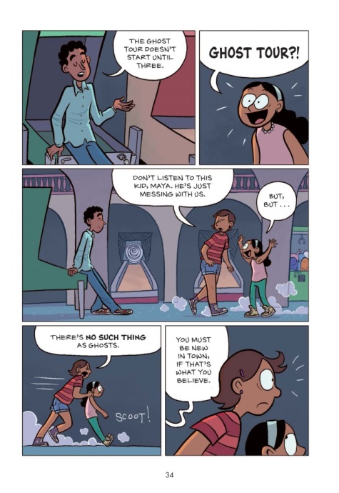
Thanks for reading. I hope you enjoy taking this journey with me.

